Define
linear momentum (and appreciate the vector nature of momentum) | as the product of mass and velocity
net force on a body | as equal to rate of change of its momentum;  Force changes the momentum of / accelerates / decelerates the object.
impulse of a force | Area under a force/time graph. Force x time for which the force acts / duration of collision
a perfectly elastic collision | A collision with no change/loss of kinetic energy. Kinetic energy is conserved,
an inelastic collision | Total energy is conserved though some loss of kinetic energy (during collision). The magnitude of the impulse on each object is the same.
the radian | The angle where the arc of a circle equals the radius.
gravitational field strength (g) | Force per unit mass (at a point in a gravitational field)
the period of an object describing a circle | The time taken for the object to describe a complete circle/orbit
geostationary orbit of a satellite | Equatorial orbit  Same period as Earth (fixed point above the Earth’s surface)
displacement | Is the distance of a body from the equilibrium position and is directed in the opposite direction to the displacement (equilibrium when the resultant force is zero)
amplitude | Is the maximum displacement
period | Time taken to compete one oscillation/cycle
frequency | Number of oscillations/cycles per unit time
angular frequency | Product of 2π x frequency or 2π/period
phase difference | The angle, in radians between subsequent wave peaks
simple harmonic motion | Acceleration is (directly) proportional to displacement (from the equilibrium position) and is always acting towards the equilibrium position.
pressure | Of a gas: Collisions with surface of large numbers of particles travelling randomly exerts a force (or each collision has a change of momentum)  Pressure = Force / Area
internal energy | The sum of the randomly (distributed) kinetic and potential energies associated with the molecules/atoms of a system
specific heat capacity | Energy required to raise the temperature of a unit mass of a substance by unit temperature rise
The newton | The force which gives a mass of 1kg an acceleration of 1 ms⁻²
Kilowatt-hour | 1kWh is the energy used/provided by a 1 kW device in 1 hour

State
The uses of geostationary satellites | Communication  Weather
Newton's three laws of motion | 1st: A body will remain at rest or continue to move with constant velocity unless acted upon by a force  2nd: Force is proportional to rate of change of momentum  3rd: When one body exerts a force upon another, the other body exerts and equal bot opposite force on the first body
the principle of conservation of momentum | (linear momentum) Total momentum is conserved.  For a closed system / no external forces
Newton’s law of gravitation | Force between two (point) masses is proportional to the product of masses and inversely proportional to the square of the distance between them.
Boyle’s law | Pressure is inversely proportional to volume for a fixed mass of gas at a constant temperature
that absolute zero is the temperature at which a substance has minimum internal energy.
the basic assumptions of the kinetic theory of gases; | Volume of particles negligible compared to volume of container OR molecules much smaller than distance between them.  No intermolecular forces (except during collision) OR molecules only have kinetic energy.  Elastic collisions  Particles travel at a constant, rapid velocity (in straight lines) between collisions OR effect of gravity is small  Time of collision is much smaller than time between collision.  Gas consists of a large number of molecules moving randomly
that one mole of any substance contains 6.02 × 10²³ particles and that 6.02 × 10²³ mol⁻¹ is the Avogadro constant N_{A}

Explain
that F = ma is a special case of Newton’s Second Law | When the mass is constant, the rate of change of momentum (mass x velocity / time) can be expressed as mass x acceleration.
using the kinetic model explain the pressure exerted by gases | See ‘pressure’ definition earlier
that whilst the momentum of a system is always conserved in the interaction between bodies, some change in kinetic energy usually occurs. | Changes in kinetic energy occur because not all collisions are perfectly elastic, some energy is lost in deformation, thermal changes etc
that a force perpendicular to the velocity of an object will make the object describe a circular path; | (Resultant) force acts perpendicular to velocity (towards the centre)
what is meant by centripetal acceleration and centripetal force; | Velocity or direction is always changing  Acceleration is in the direction of the force OR towards the centre/perpendicular to velocity
that close to the Earth’s surface the gravitational field strength is uniform and approximately equal to the acceleration of free fall; | 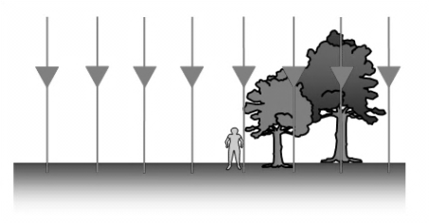  Close to Earth, field lines are effectively parallel and therefore uniform.  www.tap.iop.org
that the period of an object with simple harmonic motion is independent of its amplitude; | T = 2 π √m/k
that the rise in temperature of a body leads to an increase in its internal energy; | The total internal energy of a substance is the kinetic energy and the potential energy. Only kinetic energy contributes to temperature.
that a change of state for a substance leads to changes in its internal energy but not its temperature; | See latent heats of fusion and vaporisation
that thermal energy is transferred from a region of higher temperature to a region of lower temperature;
that regions of equal temperature are in thermal equilibrium; | No net heat flow between objects
that the mean translational kinetic energy of an atom of an ideal gas is directly proportional to the temperature of the gas in kelvin; | E = 3/2kT KE = 1/2mv²  3/2kT = 1/2mv² (3/2k is a constant)  T is proportional to KE

Recall
that the area under a force against time graph is equal to impulse;
the equation: impulse = change in momentum.

Use
gravitational field lines to represent a gravitational field; | www.tap.iop.org

Derive
the equation  T²={4π²/GM} r³  from first principles; | F = GMm/r² = mv²/r (v² = GM/r)  T = 2πr/v hence T² = 4π²r²/v²  Substitute for v²: T² = 4π²r²r/GM etc

Describe
how a mass creates a gravitational field in the space around it; | 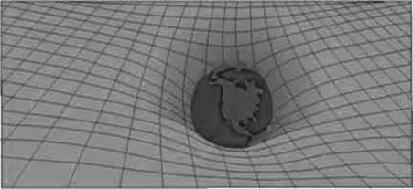  F = GM/r²
simple examples of free oscillations; | Pendulum, mass on a spring
Describe, with graphical illustrations, the changes in displacement, velocity and acceleration during simple harmonic motion; | 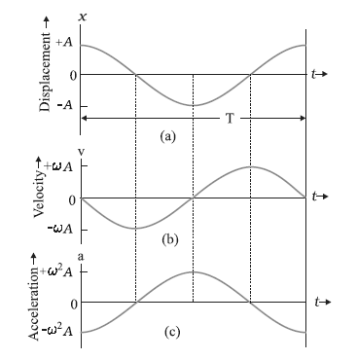  http://physicspractice.blogspot.com
the interchange between kinetic and potential energy during simple harmonic motion; | 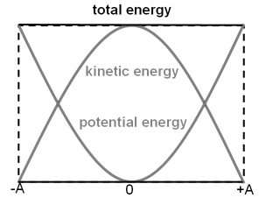  tap.iop.org
the effects of damping on an oscillatory system; | Damping an effect that reduces the amplitude of oscillations
practical examples of forced oscillations and resonance; | Where a force is continually applied resulting in resonance. For example Barton’s pendulums or a wine glass.
graphically how the amplitude of a forced oscillation changes with frequency near to the natural frequency of the system; | 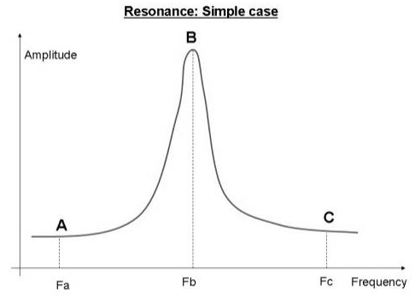
examples where resonance is useful and other examples where resonance should be avoided. | Useful: microwaves cause water molecules to vibrate. Woodwind reed/lips cause air column to resonate. MRI radio waves cause nuclei to vibrate  Problem: walking in step on a bridge. Engine vibrations causing car to shake. Earthquake ground vibrations causing buildings to collapse, poorly designed washing machine.
solids, liquids and gases in terms of the spacing, ordering and motion of atoms or molecules; | 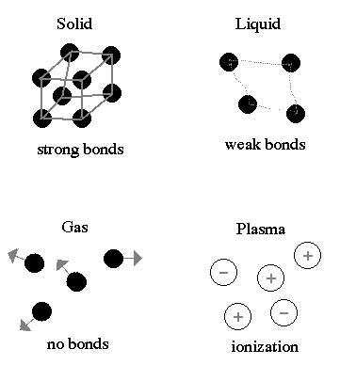
a simple kinetic model for solids, liquids and gases; | See previous
an experiment that demonstrates Brownian motion and discuss the evidence for the movement of molecules provided by such an experiment; | Movement of smoke particles caused by being hit by randomly moving, different speed, air molecules  Smoke particles are constantly moving because the air particles are continuously moving  Smoke particles are visible but air molecules aren’t hence air molecules must be very small  Small movement of smoke particles is due to the large numbers of air molecules hitting from all sides
Describe, using a simple kinetic model for matter, the terms melting, boiling and evaporation. | 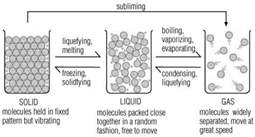  http://www.talktalk.co.uk
how there is an absolute scale of temperature that does not depend on the property of any particular substance (ie the thermodynamic scale and the concept of absolute zero); | 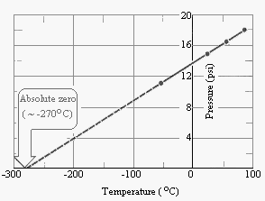  http://nothingnerdy.wikispaces.com
an electrical experiment to determine the specific heat capacity of a solid or a liquid; | Must show liquid in vessel with electrical heater with thermometer, ammeter and voltmeter  Measure mass of liquid, temperature change, values of I, V & t.  Rearrange E=mcΔθ  Identify uncertainties  Note ‘specific’ means ‘per unit mass’.
what is meant by the terms latent  heat of fusion and latent heat of vaporisation. | Latent Heat of Fusion: Thermal energy required to change (a substance) from solid into a liquid (at constant temperature).  Latent Heat of vaporisation: Thermal energy required to change (a substance) from liquid into a gas / vapour (at constant temperature)

